Assignment 1

Task-2: Prepare a prototype design of a website in Figma which contains at least 8-10 Screen or maximum as required.

Screen:-1 Food Menu

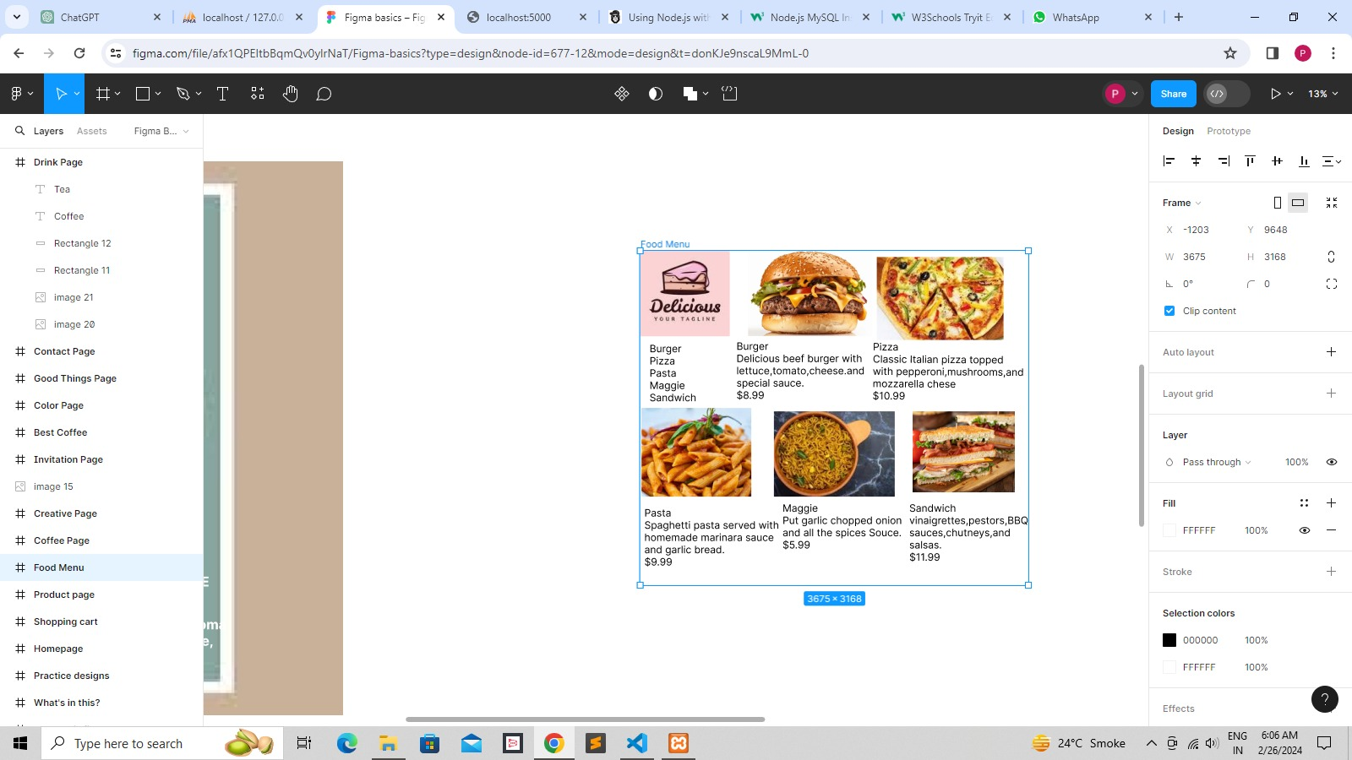

Screen:-2 Coffee Page

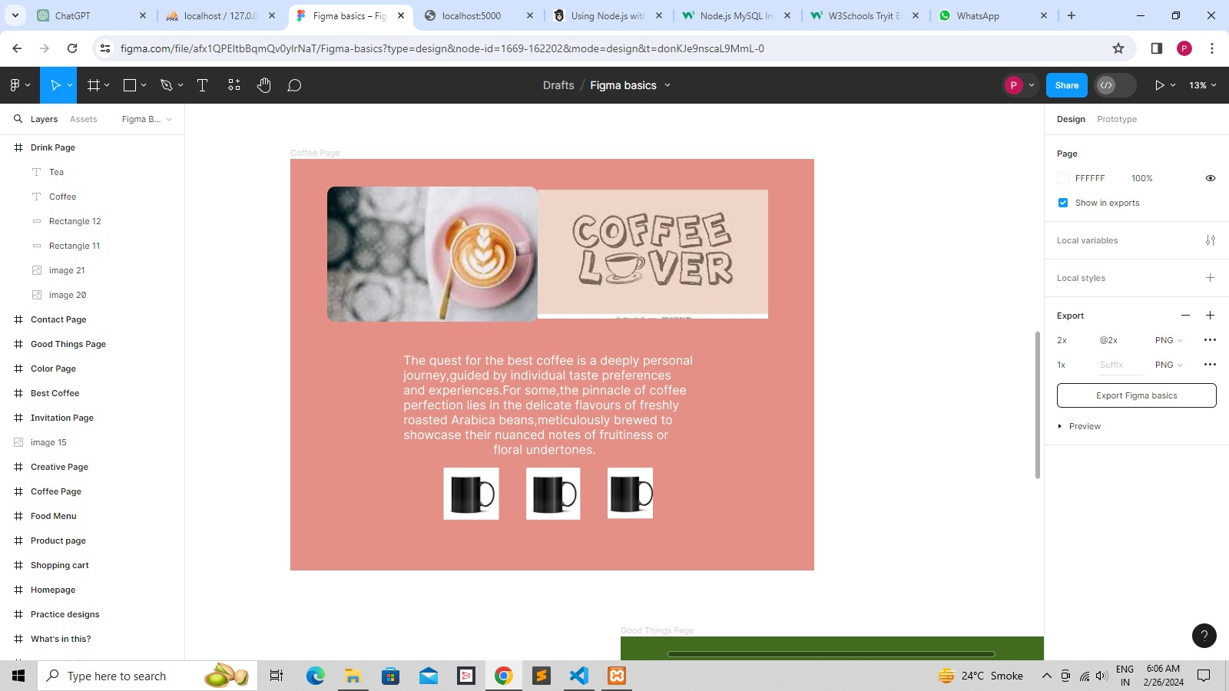

Screen:-3 Best Coffee

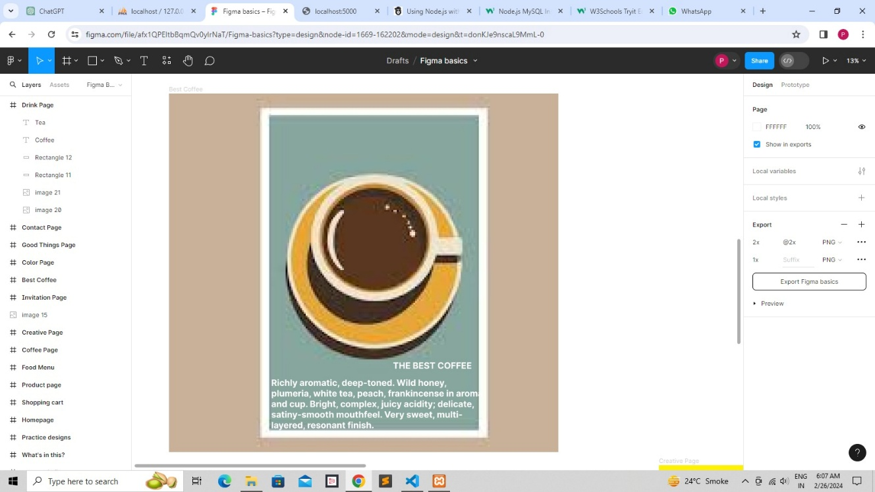

Screen:-4 Color Page

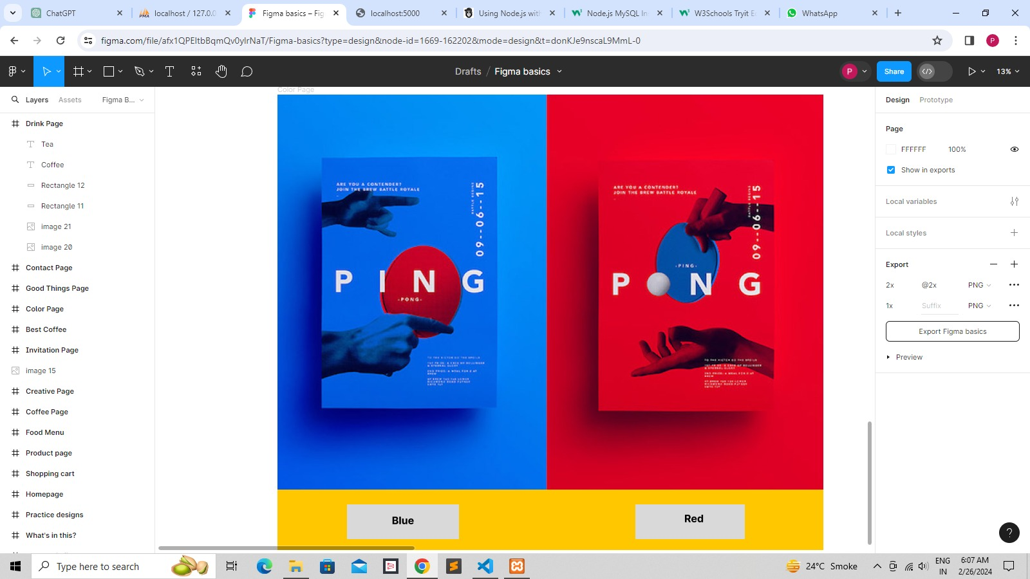

Screen:-5 Creative Page

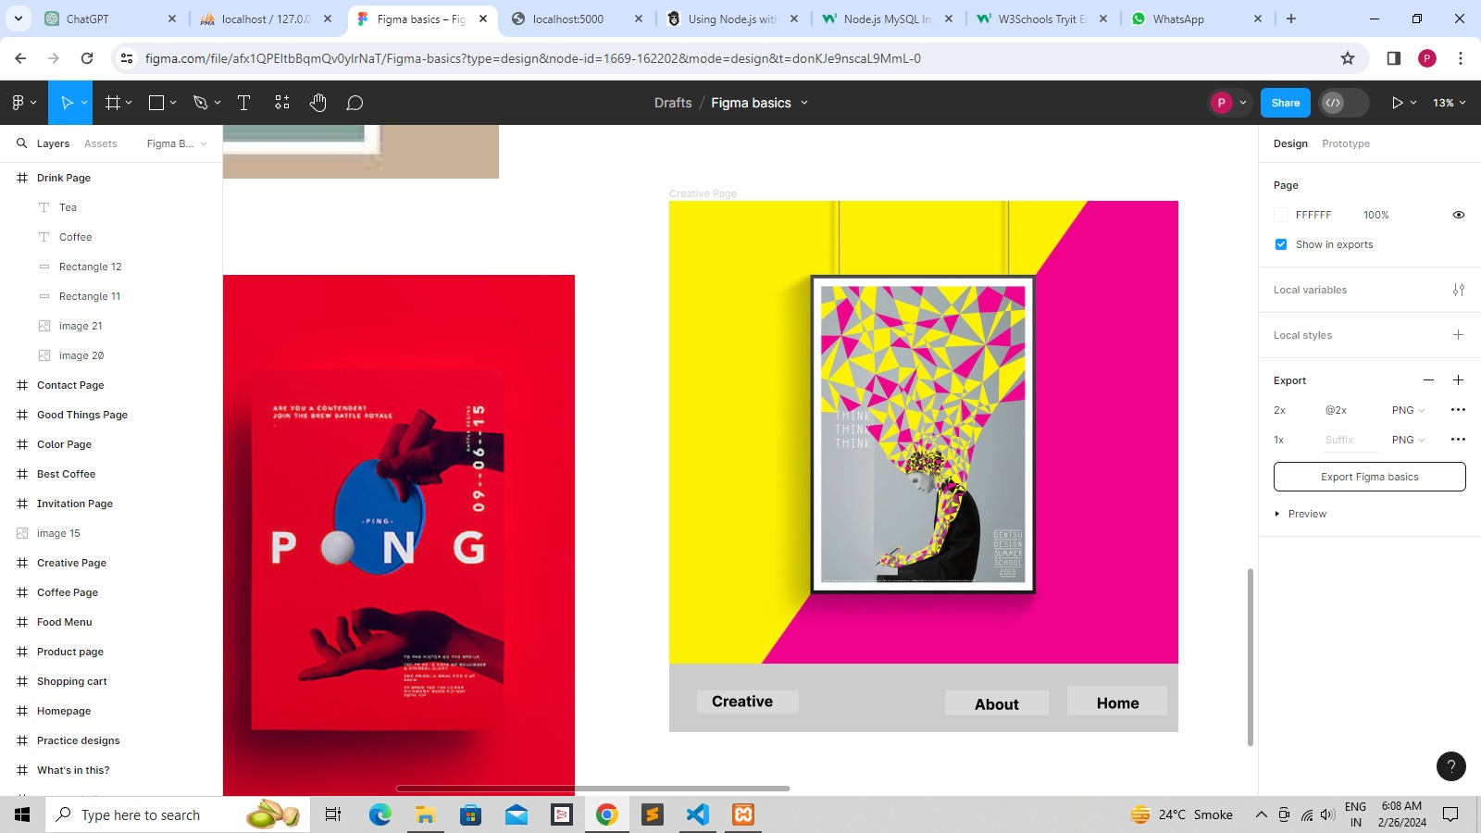

Screen:-6 Good things Page

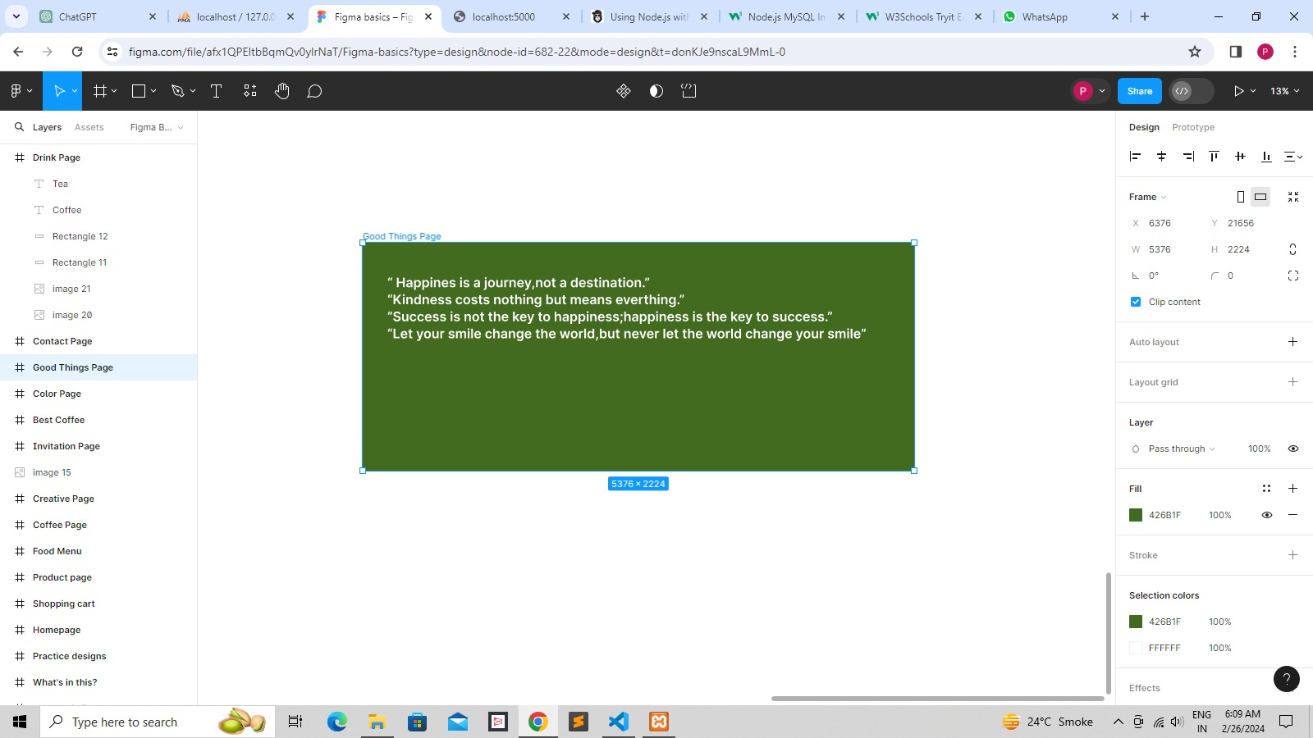

Screen:-7 Contact Page

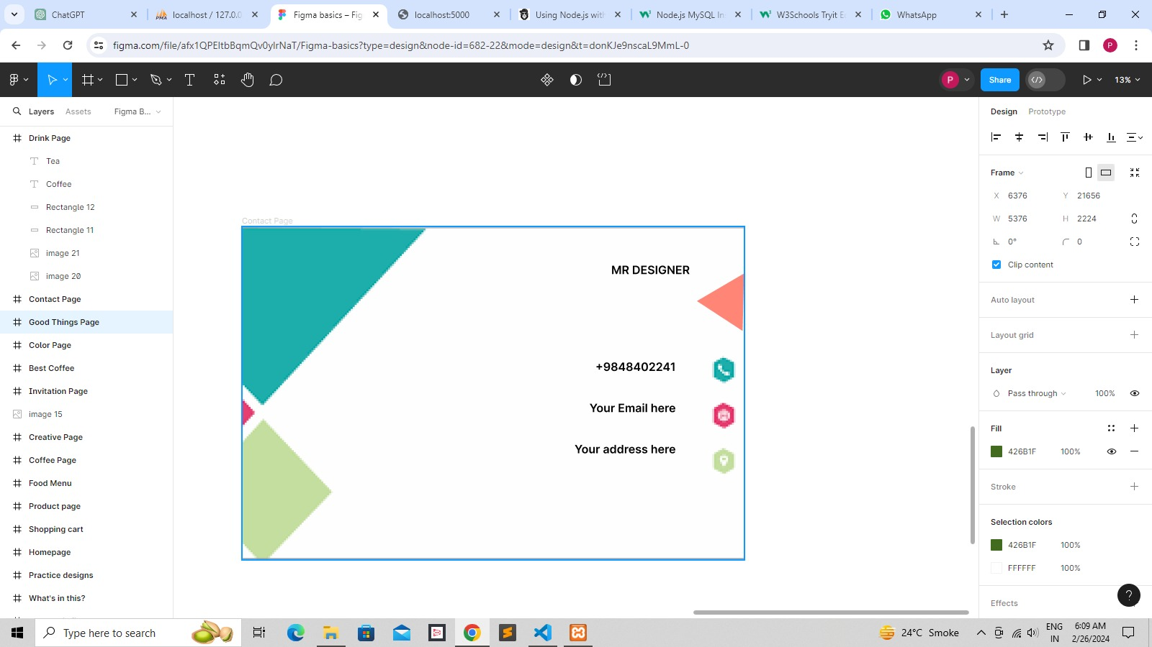

Screen:-8 About this file

